Nhóm 12

**HOẠT ĐỘNG NHÓM THỰC HIỆN**

1. **Bảng phân công công việc**

| MaSV | Họ tên | Mô tả công việc được giao | Ghi chú |
| --- | --- | --- | --- |
| 2015722 | Lê Anh Khôi | Câu 1a, 1b, 1c | Nhóm trưởng |
| 2011353 | Trịnh Ngọc Hoàng Anh | Câu 1d, 1e, 1f | Thư ký |
| 2015597 | Đoàn Quang Huy | Câu 10, 2a |  |
| 2011438 | Hoàng Ngọc Minh Thắng | Câu 2b, 2c |  |

1. **Nội dung thực hiện**

**1a. S = (p ∧ q) ∨ (p ∧ r) ∨ (p ∧ s)**

* Mạch số hiện thực biểu thức:

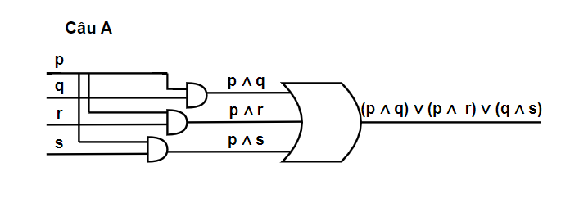

* Bảng chân trị:

| **p** | **q** | **r** | **s** | **p∧q** | **p∧r** | **p∧s** | **p∧r∨p∧s** | **p∧q∨p∧r∨p∧s** |
| --- | --- | --- | --- | --- | --- | --- | --- | --- |
| **1** | **1** | **1** | **1** | **1** | **1** | **1** | **1** | **1** |
| **1** | **1** | **1** | **0** | **1** | **1** | **0** | **1** | **1** |
| **1** | **1** | **0** | **1** | **1** | **0** | **1** | **1** | **1** |
| **1** | **1** | **0** | **0** | **1** | **0** | **0** | **0** | **1** |
| **1** | **0** | **1** | **1** | **0** | **1** | **1** | **1** | **1** |
| **1** | **0** | **1** | **0** | **0** | **1** | **0** | **1** | **1** |
| **1** | **0** | **0** | **1** | **0** | **0** | **1** | **1** | **1** |
| **1** | **0** | **0** | **0** | **0** | **0** | **0** | **0** | **0** |
| **0** | **1** | **1** | **1** | **0** | **0** | **0** | **0** | **0** |
| **0** | **1** | **1** | **0** | **0** | **0** | **0** | **0** | **0** |
| **0** | **1** | **0** | **1** | **0** | **0** | **0** | **0** | **0** |
| **0** | **1** | **0** | **0** | **0** | **0** | **0** | **0** | **0** |
| **0** | **0** | **1** | **1** | **0** | **0** | **0** | **0** | **0** |
| **0** | **0** | **1** | **0** | **0** | **0** | **0** | **0** | **0** |
| **0** | **0** | **0** | **1** | **0** | **0** | **0** | **0** | **0** |
| **0** | **0** | **0** | **0** | **0** | **0** | **0** | **0** | **0** |

**Rút gọn biểu biểu thức**

**S = p ∧ (q ∨ r ∨ s)**

| **p** | **q** | **r** | **s** | **r∨s** | **q∨r∨s** | **p∧(q∨r∨s)** |
| --- | --- | --- | --- | --- | --- | --- |
| **1** | **1** | **1** | **1** | **1** | **1** | **1** |
| **1** | **1** | **1** | **0** | **1** | **1** | **1** |
| **1** | **1** | **0** | **1** | **1** | **1** | **1** |
| **1** | **1** | **0** | **0** | **0** | **1** | **1** |
| **1** | **0** | **1** | **1** | **1** | **1** | **1** |
| **1** | **0** | **1** | **0** | **1** | **1** | **1** |
| **1** | **0** | **0** | **1** | **1** | **1** | **1** |
| **1** | **0** | **0** | **0** | **0** | **0** | **0** |
| **0** | **1** | **1** | **1** | **1** | **1** | **0** |
| **0** | **1** | **1** | **0** | **1** | **1** | **0** |
| **0** | **1** | **0** | **1** | **1** | **1** | **0** |
| **0** | **1** | **0** | **0** | **0** | **1** | **0** |
| **0** | **0** | **1** | **1** | **1** | **1** | **0** |
| **0** | **0** | **1** | **0** | **1** | **1** | **0** |
| **0** | **0** | **0** | **1** | **1** | **1** | **0** |
| **0** | **0** | **0** | **0** | **0** | **0** | **0** |

**1b. S = (p ∧ q ∧ ¬𝑟) ∨ (p ∧ ¬q ∧ 𝑟)**

| **p** | **q** | **r** | **¬r** | **q∧¬r** | **p∧q∧¬r** | **¬q** | **¬q∧r** | **p∧¬q∧r** | **p∧q∧¬r∨p∧¬q∧r** |
| --- | --- | --- | --- | --- | --- | --- | --- | --- | --- |
| **1** | **1** | **1** | **0** | **0** | **0** | **0** | **0** | **0** | **0** |
| **1** | **1** | **0** | **1** | **1** | **1** | **0** | **0** | **0** | **1** |
| **1** | **0** | **1** | **0** | **0** | **0** | **1** | **1** | **1** | **1** |
| **1** | **0** | **0** | **1** | **0** | **0** | **1** | **0** | **0** | **0** |
| **0** | **1** | **1** | **0** | **0** | **0** | **0** | **0** | **0** | **0** |
| **0** | **1** | **0** | **1** | **1** | **0** | **0** | **0** | **0** | **0** |
| **0** | **0** | **1** | **0** | **0** | **0** | **1** | **1** | **0** | **0** |
| **0** | **0** | **0** | **1** | **0** | **0** | **1** | **0** | **0** | **0** |

**Rút gọn biểu biểu thức**

**S = p ∧ (q ∧ ¬r ∨ ¬q ∧ r)**

| **p** | **q** | **r** | **¬r** | **q∧¬r** | **¬q** | **¬q∧r** | **q∧¬r∨¬q∧r** | **p∧(q∧¬r∨¬q∧r)** |
| --- | --- | --- | --- | --- | --- | --- | --- | --- |
| **1** | **1** | **1** | **0** | **0** | **0** | **0** | **0** | **0** |
| **1** | **1** | **0** | **1** | **1** | **0** | **0** | **1** | **1** |
| **1** | **0** | **1** | **0** | **0** | **1** | **1** | **1** | **1** |
| **1** | **0** | **0** | **1** | **0** | **1** | **0** | **0** | **0** |
| **0** | **1** | **1** | **0** | **0** | **0** | **0** | **0** | **0** |
| **0** | **1** | **0** | **1** | **1** | **0** | **0** | **1** | **0** |
| **0** | **0** | **1** | **0** | **0** | **1** | **1** | **1** | **0** |
| **0** | **0** | **0** | **1** | **0** | **1** | **0** | **0** | **0** |

**1c. S = (p ∧ q ∧ ¬𝑟) ∨ (p ∧ ¬q ∧ ¬𝑟)**

| **p** | **q** | **r** | **¬r** | **q∧¬r** | **p∧q∧¬r** | **¬q** | **¬q∧r** | **p∧¬q∧¬r** | **p∧q∧¬r∨p∧¬q∧¬r** |
| --- | --- | --- | --- | --- | --- | --- | --- | --- | --- |
| **1** | **1** | **1** | **0** | **0** | **0** | **0** | **0** | **0** | **0** |
| **1** | **1** | **0** | **1** | **1** | **1** | **0** | **0** | **0** | **1** |
| **1** | **0** | **1** | **0** | **0** | **0** | **1** | **1** | **0** | **0** |
| **1** | **0** | **0** | **1** | **0** | **0** | **1** | **0** | **1** | **1** |
| **0** | **1** | **1** | **0** | **0** | **0** | **0** | **0** | **0** | **0** |
| **0** | **1** | **0** | **1** | **1** | **0** | **0** | **0** | **0** | **0** |
| **0** | **0** | **1** | **0** | **0** | **0** | **1** | **1** | **0** | **0** |
| **0** | **0** | **0** | **1** | **0** | **0** | **1** | **0** | **0** | **0** |

**Biểu thức rút gọn**

**S = p ∧ ¬r**

| **p** | **r** | **¬r** | **p∧¬r** |
| --- | --- | --- | --- |
| **1** | **1** | **0** | **0** |
| **1** | **0** | **1** | **1** |
| **0** | **1** | **0** | **0** |
| **0** | **0** | **1** | **0** |

**1d. S = (p ∧ q) ∨ (p ∧ q ∧ 𝑟)**

* Mạch số hiện thực biểu thức:

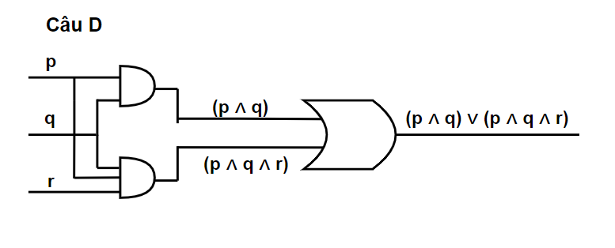

* Bảng chân trị:

| **p** | **q** | **r** | **p∧q** | **q∧r** | **p∧q∧r** | **p∧q∨p∧q∧r** |
| --- | --- | --- | --- | --- | --- | --- |
| **1** | **1** | **1** | **1** | **1** | **1** | **1** |
| **1** | **1** | **0** | **1** | **0** | **0** | **1** |
| **1** | **0** | **1** | **0** | **0** | **0** | **0** |
| **1** | **0** | **0** | **0** | **0** | **0** | **0** |
| **0** | **1** | **1** | **0** | **1** | **0** | **0** |
| **0** | **1** | **0** | **0** | **0** | **0** | **0** |
| **0** | **0** | **1** | **0** | **0** | **0** | **0** |
| **0** | **0** | **0** | **0** | **0** | **0** | **0** |

**Biểu thức rút gọn**

**S = p ∧ q**

| **p** | **q** | **p∧q** |
| --- | --- | --- |
| **1** | **1** | **1** |
| **1** | **0** | **0** |
| **0** | **1** | **0** |
| **0** | **0** | **0** |

**1.e S = (p ∧ ¬q) ∨ (p ∧ ¬𝑟)**

* Mạch số hiện thực biểu thức:

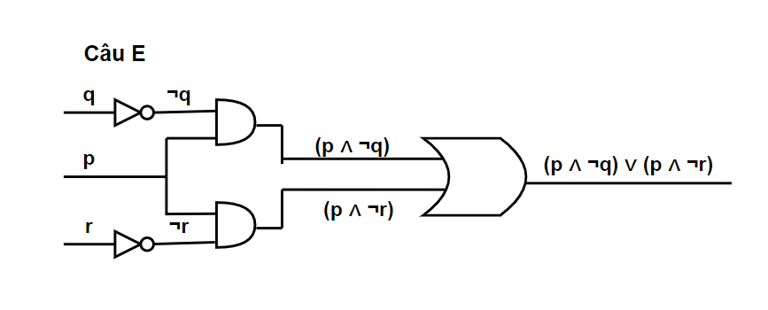

* Bảng chân trị:

| **p** | **q** | **r** | **¬q** | **p∧¬q** | **¬r** | **p∧¬r** | **p∧¬q∨p∧¬r** |
| --- | --- | --- | --- | --- | --- | --- | --- |
| **1** | **1** | **1** | **0** | **0** | **0** | **0** | **0** |
| **1** | **1** | **0** | **0** | **0** | **1** | **1** | **1** |
| **1** | **0** | **1** | **1** | **1** | **0** | **0** | **1** |
| **1** | **0** | **0** | **1** | **1** | **1** | **1** | **1** |
| **0** | **1** | **1** | **0** | **0** | **0** | **0** | **0** |
| **0** | **1** | **0** | **0** | **0** | **1** | **0** | **0** |
| **0** | **0** | **1** | **1** | **0** | **0** | **0** | **0** |
| **0** | **0** | **0** | **1** | **0** | **1** | **0** | **0** |

**Biểu thức rút gọn**

**S = p ∧ ¬(q ∧ r)**

| **p** | **q** | **r** | **q∧r** | **¬(q∧r)** | **p∧¬(q∧r)** |
| --- | --- | --- | --- | --- | --- |
| **1** | **1** | **1** | **1** | **0** | **0** |
| **1** | **1** | **0** | **0** | **1** | **1** |
| **1** | **0** | **1** | **0** | **1** | **1** |
| **1** | **0** | **0** | **0** | **1** | **1** |
| **0** | **1** | **1** | **1** | **0** | **0** |
| **0** | **1** | **0** | **0** | **1** | **0** |
| **0** | **0** | **1** | **0** | **1** | **0** |
| **0** | **0** | **0** | **0** | **1** | **0** |

**1.f S = ¬(p ∨ q) ∨ ¬(p ∨ r)**

* Mạch số hiện thực biểu thức:

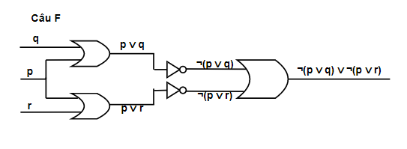

* Bảng chân trị:

| **p** | **q** | **r** | **p∨q** | **¬(p∨q)** | **p∨r** | **¬(p∨r)** | **¬(p∨q)∨¬(p∨r)** |
| --- | --- | --- | --- | --- | --- | --- | --- |
| **1** | **1** | **1** | **1** | **0** | **1** | **0** | **0** |
| **1** | **1** | **0** | **1** | **0** | **1** | **0** | **0** |
| **1** | **0** | **1** | **1** | **0** | **1** | **0** | **0** |
| **1** | **0** | **0** | **1** | **0** | **1** | **0** | **0** |
| **0** | **1** | **1** | **1** | **0** | **1** | **0** | **0** |
| **0** | **1** | **0** | **1** | **0** | **0** | **1** | **1** |
| **0** | **0** | **1** | **0** | **1** | **1** | **0** | **1** |
| **0** | **0** | **0** | **0** | **1** | **0** | **1** | **1** |

**Biểu thức rút gọn**

**S = ¬p ∧ ¬q ∧ ¬r**

| **p** | **q** | **r** | **¬p** | **¬q** | **¬r** | **¬q∧¬r** | **¬p∧¬q∧¬r** |
| --- | --- | --- | --- | --- | --- | --- | --- |
| **1** | **1** | **1** | **0** | **0** | **0** | **0** | **0** |
| **1** | **1** | **0** | **0** | **0** | **1** | **0** | **0** |
| **1** | **0** | **1** | **0** | **1** | **0** | **0** | **0** |
| **1** | **0** | **0** | **0** | **1** | **1** | **1** | **0** |
| **0** | **1** | **1** | **1** | **0** | **0** | **0** | **0** |
| **0** | **1** | **0** | **1** | **0** | **1** | **0** | **0** |
| **0** | **0** | **1** | **1** | **1** | **0** | **0** | **0** |
| **0** | **0** | **0** | **1** | **1** | **1** | **1** | **1** |

**2b. S = [([(p ∧ q) ∧𝑟] ∨ [(𝑝 ∧ 𝑟) ∧¬𝑟) ∨ ¬𝑞]→𝑠**

S= [(p ∧ q ∧ 𝑟) ∨ (𝑝 ∧ 𝑟 ∧ ¬𝑟) ∨ ¬𝑞] → 𝑠

S= ¬[(p ∧ q ∧ 𝑟) ∨ ¬𝑞] ∨ 𝑠

S= (¬p ∨ ¬q ∨ ¬r) ∧ (q ∨ s)

* **Biểu diễn sơ đồ mạch:**
* **Lập bảng đầu vào, đầu ra (1he input - output table)**

| **p** | **q** | **r** | **s** | **(¬p ∨ ¬q ∨ ¬r) ∧ (q ∨ s)** |
| --- | --- | --- | --- | --- |
| **0** | **0** | **0** | **0** | **1** |
| **0** | **0** | **0** | **1** | **1** |
| **0** | **0** | **1** | **0** | **1** |
| **0** | **0** | **1** | **1** | **1** |
| **0** | **1** | **0** | **0** | **1** |
| **0** | **1** | **0** | **1** | **1** |
| **0** | **1** | **1** | **0** | **1** |
| **0** | **1** | **1** | **1** | **1** |
| **1** | **0** | **0** | **0** | **1** |
| **1** | **0** | **0** | **1** | **1** |
| **1** | **0** | **1** | **0** | **0** |
| **1** | **0** | **1** | **1** | **1** |
| **1** | **1** | **0** | **0** | **1** |
| **1** | **1** | **0** | **1** | **1** |
| **1** | **1** | **1** | **0** | **0** |
| **1** | **1** | **1** | **1** | **1** |

**2c. S = [¬((¬p ∧ ¬q)→(¬r))∨ ¬(r→(p ∨ r))] ∨ q**

S= ((p ∧ q)∨ r) ∨ ¬(¬r∨(p ∧ r))∨ q

S= ((p ∧ q)∨ r) ∨(¬r ∧ (¬p ∨ ¬r) ∨ q

S= ((p ∧ q)∨ r) ∨ (¬p ∨ q)

* **Biểu diễn sơ đồ mạch**
* **Lập bảng đầu vào, đầu ra (the input - output table)**

| **p** | **q** | **r** | ((p ∧ q)∨ r) ∨ (¬p ∨ q) |
| --- | --- | --- | --- |
| **0** | **0** | **0** | **1** |
| **0** | **0** | **1** | **1** |
| **0** | **1** | **0** | **1** |
| **0** | **1** | **1** | **1** |
| **1** | **0** | **0** | **1** |
| **1** | **0** | **1** | **1** |
| **1** | **1** | **0** | **1** |
| **1** | **1** | **1** | **1** |